Assignment #1: Linear Regression/Scatterplot
Charles Titus
Grand Canyon University: LDR – 825
November 6, 2019

- Open SPSS and complete the following:
Obtain an output with a simple linear regression and a scatterplot graph (as in the tutorial, with the values as seen below); highlight the model summary and coefficients table, and upload it into LC:

- Obtain an output with a simple linear regression and a scatterplot graph (as in the tutorial) using the values as seen below.
Caffeine Dose IQ Score
50 100
60 102
80 107
90 105
110 112
150 108
150 103
160 109
180 109
200 112
200 120
210 114
210 118
220 121
220 120
250 130
260 127
260 131
280 132
300 135
Figure 1: Scatter-plot graph:

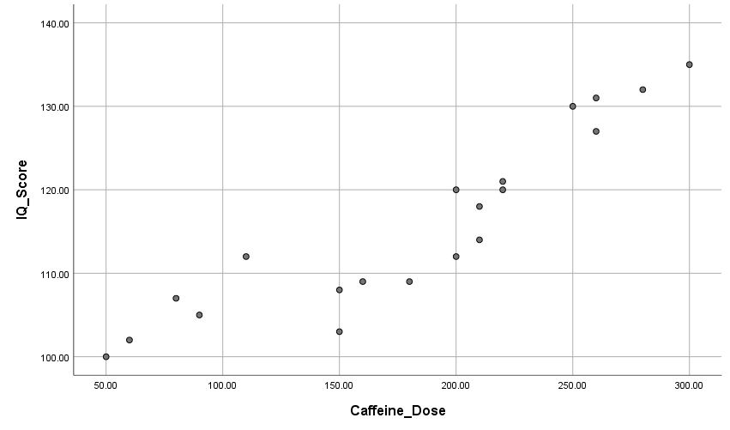

Regression Analysis

Table 1: Model Summary

Model Summary
Model | R | R Square | Adjusted R Square | Std. Error of the Estimate
1 | .917ª | .840 | .831 | 4.46113
a. Predictors: (Constant), Caffeine_Dose

Table 2: Coefficients (a)

Coefficientsª
Model |  | Unstandardized Coefficients |  | Standardized Coefficients | t | Sig.
 |  | B | Std. Error | Beta
1 | (Constant) | 91.308 | 2.705 |  | 33.761 | .000
 | Caffeine_Dose | .134 | .014 | .917 | 9.723 | .000
a. Dependent Variable: IQ_Score

Table 3: Anova (Not Required per directions but included)

ANOVAª
Model |  | Sum of Squares | df | Mean Square | F | Sig.
1 | Regression | 1881.519 | 1 | 1881.519 | 94.541 | .000^{b}
 | Residual | 358.231 | 18 | 19.902
 | Total | 2239.750 | 19
a. Dependent Variable: IQ_Score
b. Predictors: (Constant), Caffeine_Dose

Discussion of data:

There are a couple of ways that the data that has been computed in the figure and the tables above can be analyzed. First, the scatter plot can be looked at and analyzed to determine that it actually indicates that there is indeed a significant positive linear trend between the y-variable which is IQ scores and the x-variable which is caffeine doses.
One can also look at the model summary and see that this can show us some important information about the data in question. For example, R is found to be .917 which can be rounded to .92. This .92 also shows that there is a very strong positive correlation between the variables in question. By looking at the R2 which is the Coefficient of determinant of the data. In the table we can see that the coefficient of determinant is .84 which can be looked at as 84% of dependent variable which is IQ scores can be explained by the independent variable which is the caffeine dose. By knowing this one can then determine that 16% that is remaining would be other factors that have an influence on the IQ scores.

